# Department of Computing

**CS110: Fundamentals of Computer Programming**

**Class: BSCS – 6AB**

# Lab 11: Arrays, Strings and Pointers

**Date: December 28th, 2015**

**Time: 10:00 AM – 1:00 PM and 02:00 PM – 05:00 PM**

# Instructor: Dr Anis Ur Rehman

# 

# Lab 11: Arrays, Strings and Pointers

**Introduction**

In this lab, we will explore arrays, strings and pointers.

**Objectives**

To develop skills for implementing arrays and strings.

**Tools/Software Requirement**

Microsoft Visual Studio 2013

**Description**

You must do this work individually. For help use your lecture slides or you can ask for help from the TAs. You will be evaluated based on coding and C statements used in the lab tasks.

**Lab Task 1**

Write a C program to cyclically permute the elements of an array A. i.e. the content of A1 become that of A2, A2 contains A3 & so on as An contains A1.

**Output**

Enter the value of n = 5  
Enter the numbers  
10  
30  
20  
45  
18

Cyclically permuted numbers are given below  
30  
20  
45  
18  
10

**Lab Task 2**

Write a program that asks for a person’s first name and last name separately. The program must then store the full name inside a single string and output it to the string.  
i.e. Input: John   
Smith  
Output: John Smith  
The program should then replaces every a, e, i , o, u with the letter $.  
i.e. John Smith -> J$hn Sm$th

**Lab Task 3**

Write and execute the following code and then try and understand pointers basics.

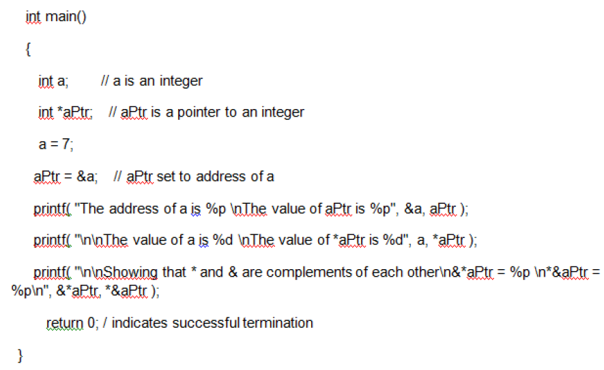

**Deliverables**

You have to submit your source code files on LMS to complete the lab.